**CHAPTER I**

**THE PROBLEM AND REVIEW OF RELATED LITERATURE**

**Introduction**

Electric fan is one of the most popular electrical appliances used as cooling system, mostly in tropical locations (e.g. Philippines). Furthermore, fans were used more often than air conditioners because of its cost-effectiveness, lower power consumption and ventilation efficiency (Ilorin Journal of Science, Volume A 2015). Unfortunately, during the recent years, the consumption of energy worldwide has been recorded to increase from generation to generation. As of March 28, 2019, the energy demand worldwide had grown by 2.3% last year (Global Energy Demand Rose by 2.3% in 2018, Its Fastest Pace in the Last Decade; 2019). However, the global electricity demand had grown for about 4% in 2018; the rapid rise pushes it towards 20% share to the total energy consumption (International Energy Agency or IEA).

“We have seen an extraordinary increase in global energy demand in 2018, growing at its fastest pace this decade,” said Dr. Fatih Birol (IEA’s Executive Director).

In accord to what the International Energy Agency’s Executive Director had said, the increasing demand for energy had come from higher demand for cooling caused by global warming. Global warming, however, is defined as the phenomenon of increasing average air temperatures near the surface of earth over the past one to two centuries (Global Warming Earth Science; Michael E. Mann and Henrik Selin). As a result, the average summer temperatures in most regions exceeded historical records; the demand for electricity had grown excessively as a consequence.

One of the reasons of this increasing electricity demand is the rapid urbanization, which result in a substantial energy consumption; confirmed by the United Nations (UN). Furthermore, the UN estimated that the world’s population will grow from 7.6 billion (7 600 000 000) in 2017 to 9.7 billion (9 700 000 000) by 2050. Consequently, most countries worldwide are experiencing energy crisis.

Energy crisis is usually defined as a shortfall in or interruption to the provision of energy supplies (Collins dictionary). According to the analysis of IEA, 1.1 billion people across the world still lack electricity supply. In the news written by Ronnel W. Domingo (May 2019), the Manila Electric Co. chair, Manuel V. Pangilinan stated that for the next years, Filipinos might experience serious energy shortage.

“The continuing Yellow and Red Alerts [in the Luzon grid] being experienced today may eventually lead to a serious power supply shortage in the next few years, unless immediate action is done to resolve the root cause of the problem, by adding more generating capacity and taking decisive action on the much-delayed construction of new power plants,” he added. His statement was concluded from Meralco’s record of previous (2019) electricity consumption in the country which exceeded the energy consumption by 2018, from 7,399 megawatt (MW) to 7,493 megawatt (MW) which reached a red alert warning.

To treat this problem, the researchers want to introduce the energy saving potential of electric fans when they were able to sense the temperature present in a room and control the speed of the fan depending on the temperature they sensed. Unlike traditional electric fans, an automatic temperature-sensing fan can automatically adjust its fan speed when the temperature increases or decreases, in other words, when enough cooling or ventilation has been given by the fan, and sensed that the temperature dropped, it will automatically decelerate the fan speed. Meanwhile, an energy efficient technology will not just only cost you lower but will also help save the world from a serious energy crisis.

To sum up, the increasing rate of energy consumption especially electricity had alarmed us to take the step in resolving the problem. Therefore, the study wants to determine if an automatic temperature-sensing fan can reduce electricity consumption and might as well help in saving electricity.

**Review of Related Literature**

The following studies and literatures are believed to be related to the study and cited to support the study being conducted.

**Background of Automatic Temperature-Sensing Fan**

Different personal cooling systems had been evaluated in an office environment during 2017 by He et.al., and found that desktop fans were very energy efficient. Also, in combination with a reflective cooling desk, they extended the employee's thermal comfort range. However, desk fans fit best in hot and dry environments if the air temperature is not much above 40o Celsius (C). At any humidity level, increased airflow is always beneficial at 34o C air temperature or below with minimal clothing.

According to Oduah U.I. and Osuntola F.O.(2015), in their research project, they designed and constructed an efficient, cheap, ATCF (Automatic temperature-controlled fan). The fan blades operating speed automatically adapts to the ambient temperature with the aid of temperature sensor which controls the fan regulator. Consequently, the speed of revolution of the fan blades were determined by the temperature of the environment, automatically increase when the temperature rises and reduce when the temperature drops.

Due to sudden undesirable fluctuations in the temperature of the environment, this innovation targeted at overcoming the challenges posed by the conventional fan by   
requiring one to be alerted at all times to switch the fan. Where sudden change in weather conditions caused by rain, harmattan, heavy sun, wind etc. may result into sudden change in temperature. Unfortunately, some people may not be alert and able to operate the manually regulated electric fan when the need arises. So, the automatic temperature controlled electric fan is most suitable and desirable for the household and other locations.

The ATC fan is efficient and relatively cheap. An additional remote-control circuit and voice command circuit can be included to improve comfort of the operator at his/her own convenience under the manual mode.

When it is hot, usage of fan is more convenient than spending more on air conditioners especially in some areas where high temperature is normal. Some problems, like the annoyance and frustration of the user when getting up to adjust the speed of the fan and users tend to forget to turn off the device when being away. These may result in a rise of electricity bill and may cause disaster, fire for example. A prototype of smart fan was built in this research using ESP8266 as a microcontroller, DHT22 and HC-SR04 are used to measure temperature for speed control and detect the user for automatic on/off respectively. A group of participants used the prototype and they were interviewed to give some feedbacks, comments, and suggestions from the experiences after using it. The results show that they were satisfied from the automation; it gave the sense of staying in a modern house with an automatic wind blower. It also assisted to reduce energy consumption according to target group. Some users stated that the environment and atmosphere in the room was not too hot because the fan was working in the background. This has shown that the prototype significantly gave the participants a feeling of relaxation and comfortability and also was a part of energy and cost reduction. (Kanchanasatian, Keeratiburt, 2018; Automatic Speed Control and Turning ON/OFF for Smart Fan by Temperature and Ultrasonic Sensor).

**The Arduino Uno (R3)**

Arduino Uno (R3) has 14 digital input/output pins (of which 6 can be used as PWM outputs), 6 analog inputs, a USB connection, a power jack, a reset button and more. It contains everything needed to support the microcontroller; simply connect it to a computer with a USB cable or power it with an AC-to-DC adapter or battery to get started.

Arduino is an open-source platform used for building electronics projects. Arduino consists of both a physical programmable circuit board (often referred to as a microcontroller) and a piece of software, or IDE (Integrated Development Environment) that runs on your computer, used to write and upload computer code to the physical board.

The Arduino platform has become quite popular with people just starting out with electronics, and for good reason. Unlike most previous programmable circuit boards, the Arduino does not need a separate piece of hardware (called a programmer) in order to load new code onto the board -- you can simply use a USB cable. Additionally, the Arduino IDE uses a simplified version of C++, making it easier to learn to program. Finally, Arduino provides a standard form factor that breaks out the functions of the micro-controller into a more accessible package.

Some researches about the Arduino and Raspberry pi were reviewed to gain knowledge about the two. It's very easy to analog sensors, motors and other electronic component with Arduino, with just few lines of code than Raspberry pi because there are much overhead for simply reading those sensors, it needs to install some libraries and software for interfacing these sensors and components. The coding of Arduino is simpler, while one needs to have knowledge of Linux and its commands for using the Raspberry pi. Raspberry Pi runs on an OS so it must be properly shut down before turning OFF the power, otherwise OS & applications may get corrupted and Pi can be damaged. While Arduino is just a plug and play device which can be turned ON and OFF at any point of time, without any risk of damage. It can start running the code again on resuming the power. For the power consumption, Pi is a powerful hardware, it needs continuous 5v power supply and it is difficult to run using batteries, while Arduino needs less power can easily be powered using a battery pack. Obviously Arduino is cheaper than Raspberry Pi, Arduino costs around $10-20 depending on the version, while price of Raspberry is around $35-40.

In conclusion, Arduino is better because it can do more simple things and it's best for beginners like the researchers. however, choice depends on the project and the background of the electronics project.

**The DHT22 Temperature-Humidity Sensor Module**

This module is a basic, low-cost digital temperature and humidity sensor. It uses a capacitive humidity sensor and a thermistor to measure the surrounding air, and outputs a digital signal on the data pin. Unfortunately, it captures new data once every 2 seconds, meaning the data gathered can possibly be about 2 seconds old (Maker-Lab Electronics).

Unlike the DHT11, the DHT22 Temperature-Humidity Sensor Module is more precise and more accurate (DHT22 has 0.1oC error <±0.5oC for every -40oC to 80oC while DHT11 has ±2°C accuracy for every 0 to 50oC). It also works in a bigger range of temperature/humidity, yet larger in size (DHT22 body size of 27mm x 59mm x 13.5mm and weighs 2.4 grams, compared to DHT11 which is only 15.5mm x 12mm x 5.5mm) and more expensive (about twice the price of DHT11).

Both of the temperature-humidity sensor is powered with either 3.3V or 5V, and is compatible for micro-controllers, like the Arduino. The DHT22 has better resolution and a wider measurement range of -40oC to 80oC, on the other hand, the DHT11 can only measure temperature that ranges from zero to 50oC. However, the DHT11 can gather readings of temperature every second, almost half the speed of the DHT22, but it is less acute than the other sensor module (Adafruit Learning System Guide).

“So, if you’re willing to spend an extra dollar, we recommend the DHT22 over the DHT11.” – Random Nerd Tutorials

**The 16x2 Liquid Crystal Display (LCD)**

A 16 by 2 LCD has the following features:

1. 5x8 dots with cursor or pixel box
2. 16 characters with 2 rows display
3. 4-bit or 8-bit MIDI Processing Unit (MPU) interfaces
4. Built-in controller
5. Display mode and Backlight variations
6. RoHS (Restriction of Hazardous Substances) Compliant

The LCD has operative voltage of 4.7V to 5.3V and very common in most embedded projects. It is programmer-friendly, cheap and available at most electronics shop. In addition, LCD’s can be seen mostly in calculators or PCO’s. 16x2 means that there are 16 columns and two rows being displayed, however, there are lot of displays like 8x1, 10x2, 16x1 etc. but the most used LCD is 16x2 which is a total of 32 characters, each character is made of 5x8 (40) pixel dots (Components 101).

**The Inter-Integrated Circuit (I2C) Module**

The features of an I2C are: (1) two-to-seven-bit format transfer, (2) Compliance with the Philips Semiconductors I2C-bus specification (version 2.1), (3) free data format mode, (4) one read DMA (direct memory access) event and one write DMA event that can be used by the DMA, (5) seven interrupts that can be used by the CPU, (6) interface to V-bus (32-bit synchronously slave bus), and (7) module enable/disable capability.

Specifically, an I2C is created to either of the following:

1. Support for byte format transfer
2. 7-bit and 10-bit addressing modes
3. General call
4. Start byte mode
5. Support for multiple master-transmitters and slave-receivers’ mode
6. Support for multiple slave-transmitters and master-receivers’ mode
7. Combined master transmits or receive and receive or transmit mode
8. I2C data transfer rate of from 10 kbps up to 400 kbps (Philips I2C rate)

In other words, the I2C module provides an interface between devices compliant with the I2C-bus specification and connected by way of an I2C-bus. External components attached to this two-wire serial bus can transmit and receive up to eight-bit wide data to and from the device through the I2C module (Texan Instruments; TMS320C6472/TMS320TCI648x DSP Inter-Integrated Circuit (I2C) Module User’s Guide).

**The Mini Breadboard**

The modern breadboard is a plug-and-play way to make connections between electronic components. In 1971, thanks to Ronald J. Portugal, we’ve had convenient plastic boards which tidily pack hundreds of tie points (also known as contacts) into a small form-factor suitable for wires, components with long leads, and socket-able components with 0.1” Dual or Single in-line pins. These tie points take the form of holes within the breadboard, into which wires and components can be pushed. Breadboards generally can withstand frequencies lower than 10 megahertz. The main use of breadboard is for prototyping for beginners because it has this feature that lets you plug and unplug jumper wires. Imagine you've just finished your device only to find that there is a wrong connection you've made if you can just unplug your jumper wires and reconnect it all once you find the wrong connection.

**The Infrared Remote (IR) Control with 1-Channel Relay Module**

This device is equipped with 12V single-channel relay compatible with 250VAC 30VDC 10A loads. Come along with 2-key IR remote control to control the relay close/open easy to operation ideal for DIY your wireless power controller system.

The board is about 50mm length, 20mm width and 20mm height or, 1.97 X 0.79 X 0.79inch(L*W*H) with a communication distance of maximum 8 meters. Furthermore, the module is operated by a 12.0 volts power (Amazon).

**The 4-Channel Relay Module**

The 4-Channel Relay Module SPDT (Single Pole Double Throw) can control up to 4 separate devices individually. Relays are typically used to switch devices which uses a higher voltage than what most micro-controllers such as an Arduino or Raspberry Pi can handle. This particular relay module can control typical household appliance up to 10A. (Hengstler.Kaco, 2017).

A relay is an electrically operated switch. Many relays use an electromagnet to mechanically operate a switch, but other operating principles are also used, such as solid-state relays. Relays are used where it is necessary to control a circuit by a separate low-power signal, or where several circuits must be controlled by one signal. Relays work on electromagnetism, When the Relay coil is energized it acts like a magnet and changes the position of the switch. The circuit which powers the coil is completely isolated from the part which switches ON/OFF, this provides electrical isolation. (J.Darbyshire, 2018). This is the reason we can control a relay using 5V’s from an arduino and the other end of it could be running a 220 to 240V appliance, the 240V end is completely isolated from the 5V arduino circuitry.

**Definition of Terms**

The following terms were defined as used in the study:

1. **Arduino Uno (R3) -** a microcontroller board based on a removable, dual-inline-package (DIP) ATmega328 AVR microcontroller.It is used mainly as the brain or the commander of the system, simply a motherboard. The code is uploaded to the Arduino to finally make the system run.
2. **DHT22 Temperature-Humidity Sensor Module –**contains the compound has been calibrated digital signal output of the temperature and humidity sensors. The module is used to sense the temperature in the environment by plugging the module (connect the 1st pin on the left to the 3-5v power, middle pin to the data input and rightmost to the ground), and is used for analog sensor interfaces.
3. **16x2 Liquid Crystal Display (LCD)** –an electronic display module which uses liquid crystal to produce a visible image. This device is used to display the data input from the DHT22 and relay.
4. **Inter-Integrated Circuit (I2C) Module -**a multi-master serial bus that connects low-speed peripherals to a motherboard, mobile phone, embedded system or other electronic devices. The I2C was connected to the 16x2 LCD to lessen the materials to be used and to be able to connect the LCD directly to the Arduino.
5. **Mini Breadboard –**a plug-and-play way to make connections between electronic components. Since there are numerous materials to be used, the Arduino cannot hold these directly in the plug. The use of mini breadboard will help the motherboard hold the modules by plugging them to the mini breadboard.
6. **Jump wires –**these arewires that have connector pins at each end, allowing them to be used to connect two points to each other without soldering. The jumper wires where used to connect the modules to the breadboard and Arduino without using a soldering iron.
7. **Infrared Remote Control with 1-Channel Relay Module –**has the ability to control (on/off) various appliances and other equipment with large current. In the study, the electric fan is operated with an alternative current meaning, it holds a large current. The IR Control best suits the device for turning it on/off from distant locations.
8. **4-Channel Relay Module –** generally the module is used as interface modules. They perform different tasks depending on the version and are used to switch circuits on, off, and over. Switching devices that are susceptible to faults compromise the availability of machines and systems. Whereas in the study, the module is used to control the speed of the fan from 1 to 3 depending on the temperature that the DHT22 detected.
9. **12V AC to DC Power Supply –**the power supple enables to convert an alternative current to direct current, specifically 12 volts. It is used to supply power to the Arduino to be able to run the device.
10. **Desk fan –**the desk fan is the main subject in the study, because it is the appliance where the system is to be installed.
11. **Epoxy Glue (Plastic) –** used to as a firm glue to attached the device in the desk fan and avoid them from falling.
12. **Transparent cover –** used to cover the internal parts which still enables us to see the device behind the cover. As well as to avoid the parts from completely falling to the ground once opened from the main cover of the desk fan.
13. **Soldering Iron and Tin Lead Wire –** Used to connect open wires and avoid short circuit and electric shock.

**Objectives of the Study**

The alarming phenomenon, the increase of consumption of energy worldwide from generation to generation, pose serious threats to the people. Hence, the study generally aims to develop an energy-efficient cooling system to lessen the consumption of electricity in the country. Moreover, the study is specifically aimed to:

1. Create an automatic temperature-sensing fan.
2. Innovate a traditional electric fan to a low-cost user-friendly automatic temperature-sensing fan for reducing the power consumption and assist people who are unable to control the speed of fan from their locations.
3. Compare and contrast traditional electric fans to an automatic temperature-sensing fan in terms of:
   1. Power-consumption
   2. Functionality
4. Determine the electricity-saving potential and cost-efficiency of an automatic temperature-sensing fan.
5. Examine the advantages of having an automatic temperature-sensing fan.

**Significance of the Study**

During the recent years, the consumption of energy worldwide has been recorded to increase from generation to generation. The recent years’ (2016 to 2018) energy consumption record had been discovered to have a rapid increase of 2% to 4%. ‘For the next years, Filipinos might experience serious energy shortage,’ the Manila Electric Co. chair, Manuel V. Pangilinan stated. In other words, due to too much consumption of energy, an energy crisis will be expected to happen for the next years worldwide, if there is no action done.

The invention of an Automatic Temperature-Sensing Fan aimed to lessen the power-consumption of the people worldwide, it also aims to help persons with disabilities or persons who were not able to control the speed of fan from their locations**.** Hence, the study will be beneficial to the following people in the society:

**The Department of Environment and Natural Resources (DENR).** The invention of an energy-efficient cooling system will help lessen the crisis in the environment therefore, help the DENR in minimizing the consumption of our natural resources. According to 2019 CIA World Factbook and Other Sources Philippines produce 86.59 billion kWh (2016 est.) and consumes 78.3 billion kWh (2016 est.) 67% of the energy produced came from fossil fuel, our product can lessen the energy consumption hence, minimizing the usage of natural resources.

**The Households.** The innovated fan is aimed to be a cost-efficient cooling system so, the study will benefit the household in terms of reducing the consumption of electricity, hence, it will help lessen the cost of monthly electricity bill of the households.

**The Persons with Disabilities (PWD’s).**The study will benefit the people with disabilities and are unable to control the speed of the electric fan as well as the turning of electric fan on and off, from their locations.

**The Aged Individuals.** The elderly especially those who have difficulties in moving, will be the beneficiary of the study. With the innovated fan, the elderly will be able to turn on and off a fan, without directly pressing on and off from the fan. As well as, the elderly can take a rest peacefully without interruption from the temperature being too hot or too cold. They will be able to take a nap without worrying about the speed of electric fan.

**The Students.** By discovering a solution to the problem, the students will be knowledgeable about the things that they can do to improve the lives of every people without harming the environment. The study will be beneficial to inform the student of the possible problems that the world will face in the future and how to possibly prevent it from happening.

**The Future Researchers.** The future researchers who would like to improve the study or conduct a similar study will have a background about the study and be able to have ideas for future projects.

**Scope and Limitation of the Study**

The study generally aims to lessen the power-consumption by developing an energy-saving cooling system. In addition the specific objectives of the study are (1) create an automatic temperature-sensing fan, (2) innovate a traditional electric fan to a low-cost user-friendly automatic temperature-sensing fan for reducing the power consumption and assist people who are unable to control the speed of fan from their locations, (3) compare and contrast traditional electric fans to an automatic temperature-sensing fan in terms of power-consumption and functionality, (4) determine the electricity-saving potential and cost-efficiency of an automatic temperature-sensing fan, and (5) examine the advantages of having an automatic temperature-sensing fan.

The study was conducted at Cabanatuan City, Nueva Ecija from December 2019 to February 2020. Mainly, the study was done at Elektronics Hub, Silangan Street, Barangay Bantug Bulalo, Cabanatuan City, Nueva Ecija 3100, to seek for further information about how the will the researchers be able to accomplish the technology, and for an assistance from a professional.

**CHAPTER II**

**METHODOLOGY**

This chapter presents the methods, procedures and processes used in the study, specifically the research design, research site, materials and instrumentation, and data collection.

**Research Design**

This study utilized an experimental research design. Experimental research designs are based on comparison between two or more groups. Likely, one of the specific objectives of the study is to compare and contrast traditional electric fans to an ATSFan. The research design is the best type of research to apply in the study because the researchers did not manipulate the variables in the study.

**Research Site**

The study was conducted in Cabanatuan City, specifically at the Electronik Hub, Silangan Street, Barangay Bantug Bulalo, Cabanatuan City, Nueva Ecija 3100. The photos below presents the location of the study.

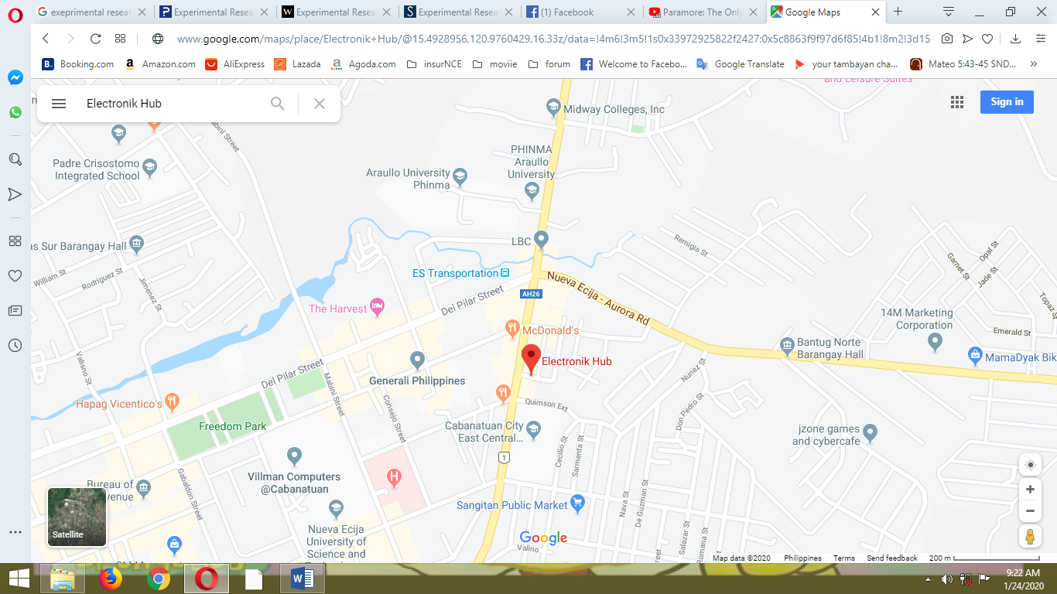

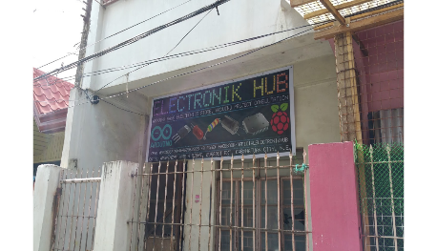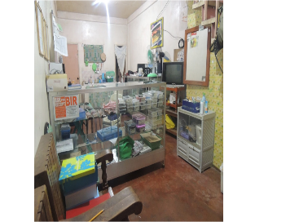

**Figure 1.**

**Research Site**

**Materials and Instruments**

The materials used in the study were presented in the table below together with the total cost of the project.

|  |  |  |  |
| --- | --- | --- | --- |
| **Materials** | **Quantity** | **Cost per Unit** | **Total** |
| Arduino Uno (R3) | 1 | 283 | 283 |
| DHT22 Temperature-Humidity Sensor Module | 1 | 189 | 189 |
| 16x2 Liquid Crystal Display (LCD) | 1 | 107 | 107 |
| Inter- Integrated Circuit (I2C) Module | 1 | 75 | 75 |
| Mini Breadboard | 1 | 49 | 49 |
| Jump wires | 40 | 3 | 120 |
| Infrared Remote Control with 1-Channel Relay Module | 1 | 150 | 150 |
| 4-Channel Relay | 1 | 159 | 159 |
| 12V AC to DC Power Supply | 1 | 82 | 82 |
| Desk fan | 1 | 1,200 | 1,200 |
| Epoxy Glue (Plastic) | 1 | 60 | 60 |
| Transparent cover | 2 | 11 | 22 |
| **Total cost:** | | | **2,496** |

**Table 1.**

**Materials used in the product**

**Arduino Uno (R3) -** a microcontroller board based on a removable dual-inline-package (DIP) microchip ATmega328 AVR microcontroller.It is used mainly as the brain or the commander of the system, simply a motherboard. The code is uploaded to the Arduino to finally make the system run.

**DHT22 Temperature-Humidity Sensor Module –**contains the compound has been calibrated digital signal output of the temperature and humidity sensors. The module is used to sense the temperature in the environment by plugging the module (connect the 1st pin on the left to the 3-5v power, middle pin to the data input and rightmost to the ground), and is used for analog sensor interfaces.

**16x2 Liquid Crystal Display (LCD)** – an electronic display module which uses liquid crystal to produce a visible image. This device is used to display the data input from the DHT22 and relay. The function of LCD is for displaying temperature and Fan speed status of the automatic temperature sensing fan.

**Inter- Integrated Circuit (I2C) Module -** a multi-master serial bus that connects low-speed peripherals to a motherboard, mobile phone, embedded system or other electronic devices. The I2C was connected to the 16x2 LCD to lessen the materials to be used and to be able to connect the LCD directly to the Arduino. The function of these device is to allow multiple electronic devices to communicate with each other over a single pair of wires or the so-called data lines.

**Mini Breadboard –** a plug-and-play way to make connections between electronic components. Since there are numerous materials to be used, the Arduino cannot hold these directly in the plug. The use of these device will help the motherboard to hold the modules by plugging to the breadboard. The function of mini breadboard is to connect the power rails or other rows from the Arduino.

**Jump wires –** these arewires that have connector pins at each end, allowing them to connect two points to each other without soldering. The jumper wires where used to connect the modules to the breadboard and Arduino without using a soldering iron.

**Infrared Remote Control with 1-Channel Relay Module –**has the ability to control (on/off) various appliances and other equipment with large current. In the study, the electric fan is operated with an alternative current meaning, it holds a large current. The IR Control best suits the device for turning it on/off from distant locations. With each press of the S1 button or the remote control of the fan, the relay module will switch working state once, turn on or off which serves as its function.

**4-Channel Relay Module –** generally the module is used as interface modules. They perform different tasks depending on the version and are used to switch circuits on, off, and over. Switching devices that are susceptible to faults compromise the availability of machines and systems. Whereas in the study, the module is used to control the speed of the fan from 1 to 3 depending on the temperature that the DHT22 detected.

**12V AC to DC Power Supply –** the power supple enables to convert an alternative current to direct current, specifically 12 volts. It is used to supply power to the Arduino to be able to run the device.

**Desk fan –** the desk fan is the main subject in the study, because it is the appliance where the system is to be installed.

**Epoxy Glue (Plastic) –** is a two-part adhesive that forms when you mix epoxy resin and hardener, by 1:1 ratio. The function of this glue is to join electrical materials together or to protect the underlying surfaces of the fan from dirt and moisture.

**Transparent cover –** used to cover the internal parts which still enables us to see the device behind the cover. As well as to avoid the parts from completely falling to the ground once opened from the main cover of the desk fan.

**Soldering Iron and Tin Lead Wire –** a device whose metal tip heats to temperatures well above the melting point of solder or the tin lead. This is used to melt the solder and allow it to flow into a joint to connect it.

**Data Collection**

After the title of the research has been approved by the SHS Faculty Head, the researchers secured the consent of the SHS principal to conduct the study.

The data collection presents how the materials and data were gathered, and how to make the device.

**Designing of "ATSFan"**

The device was designed considering the possible innovation, and both of the internal and external impacts. The researchers made the final output and started recreating the usual desk fan. Wherein, they cut the manual fan speed controller buttons (0, 1, 2, and 3) and replaced them with a 16x2 liquid crystal display, where the temperature and the fan speed were indicated. On top of that is the DHT22 Temperature-Humidity Sensor Module which is used to sense the temperature present in a particular area. Also, for the on and off of the fan, an infrared remote control was installed.

The layout of the schematic diagram, the PCB (Printed Circuit Board), and Breadboard Layout of the device was shown below:

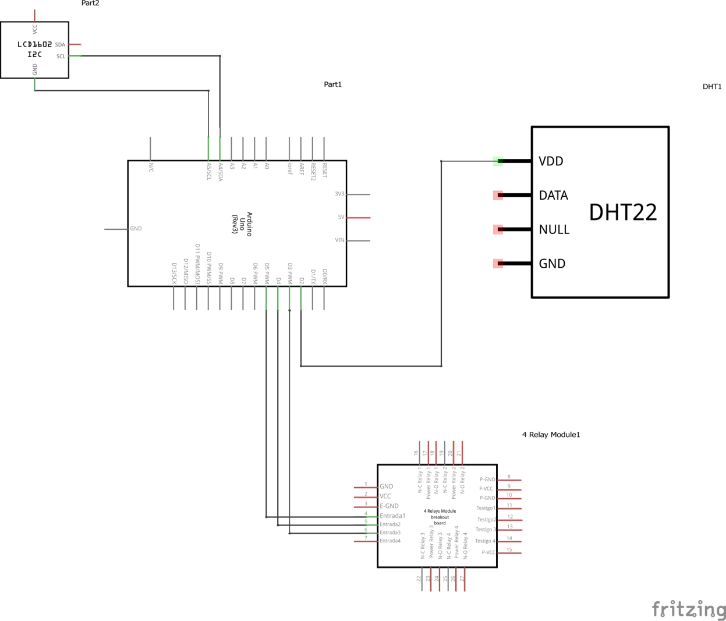

**Figure 2.**

**Schematic Diagram of Automatic Temperature-Sensing Fan**

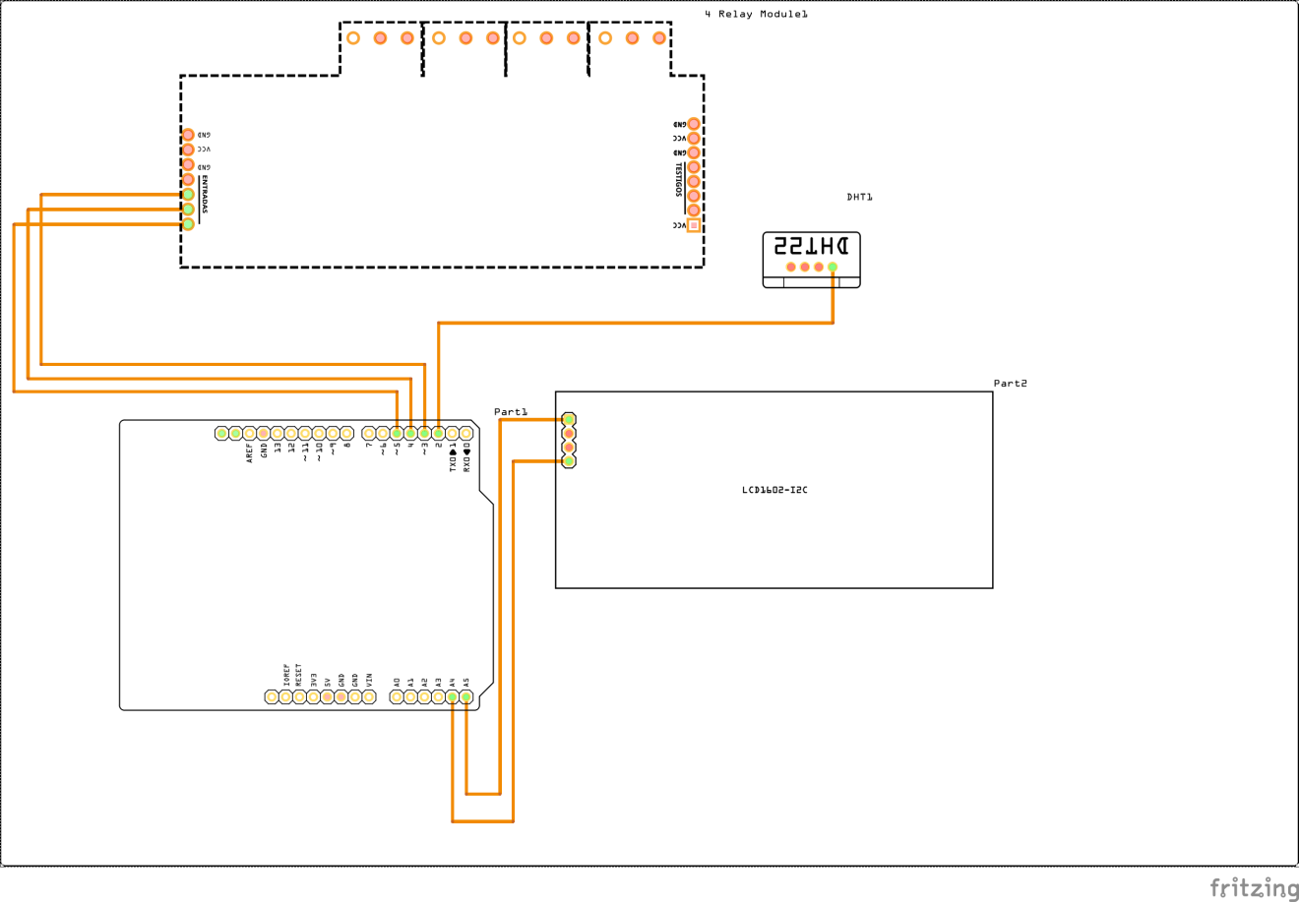

**Figure 3.**

**PCB Layout of Automatic Temperature-Sensing Fan**

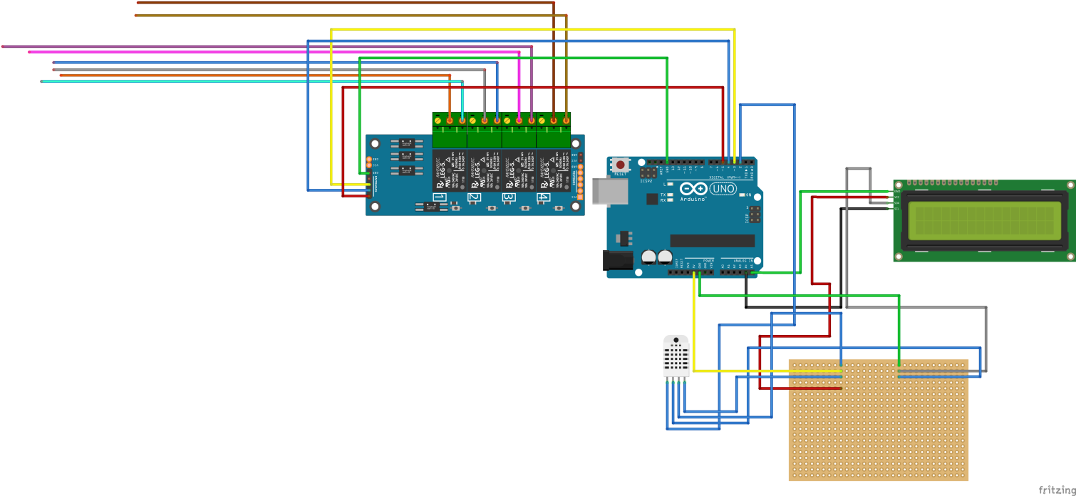

**Figure 4.**

**Breadboard Layout of the Automatic Temperature-Sensing Fan**

**Collection of Materials**

The researchers carefully picked the best combination of materials used for the fan that was chosen to protect the output from possible internal and external impact. The electronic materials specifically the Arduino used to power the entire output came from Electronik Hub and most of the components used to make the temperature sensor possible installed in the fan was bought in the same store.

**Preparation of Materials**

The materials were tested first before they were put in the fan to know if they are functioning properly. Usage of jumper wires and cables to connect the Arduino, mini breadboard, 16x2 Liquid Crystal Display (LCD), DHT22 Temperature-Humidity Sensor Module, 4-Channel Relay Module, 12V AC to DC Power Supply and the fan were tested as well. Making sure that every component was playing their own part and was working properly is an essential part to ensure its capability of saving energy before installing it in the fan.

**Making the "ATSFan"**

To successfully accomplish the product, the following steps were applied:

STEP 1: Connect the internal parts of the device. Follow the layout in figure 4)

STEP 2: Code the Arduino.

STEP 3: Upload the code to the Arduino.

STEP 4: Uninstall the buttons of a traditional desk fan.

STEP 5: Make 3 holes from the base of the desk fan. One for the LCD, one for the Temperature- humidity sensor and one for the infrared receiver.

STEP 6: Open the base of the fan and install the internal device to the base of the fan and glue them using an epoxy.

STEP 7: Check for open wires. Solder them.

STEP 8: Cut a transparent cover to make sure that the internal parts were safe.

STEP 9: Close the base of the fan. Test the device.

**Chapter III**

**Presentation, Analysis, and Interpretation of Results**

This chapter presents all the data and results gathered as well as the interpretation of findings.

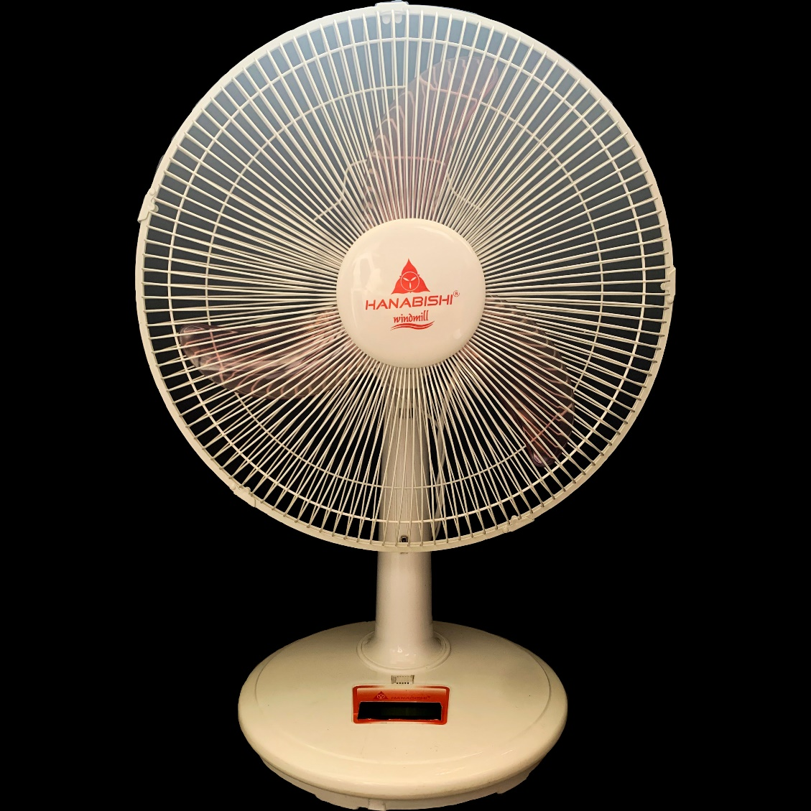

**Figure 6.**

**The Automatic Temperature-Sensing Fan**

The figure shown above is the actual product of the research study. It was made from devices that were readily available from the market costing about 2,500 (two thousand five hundred) pesos. From the external of the product, the LCD and the DHT22 can be seen clearly. These parts were used to gather data from the environment and display the information to the user. The LCD shows the temperature gathered by the DHT22 from the surrounding, and the fan speed which was commanded by the Arduino Uno to the Relay module. However, to reduce human effort, a remote-control circuit was installed to the product. This device will automatically adjust its fan speed through the temperature present in a particular area. It reduces human effort, by using the remote control to turn it on and off and lessens consumption of energy in households through automatically changing the fans peed when the temperature rises or drops.

Based on the review of related literature, Oduah U.I. and Osuntola F.O.(2015), in their research project, ATCF (Automatic temperature-controlled fan), the automatic temperature controlled electric fan is most suitable and desirable for the household and other tropical regions. They also recommend to add a remote control circuit and voice command circuit to improve comfort of the operator. Whereas in the study conducted by the researchers, an infrared remote control circuit was included.

**Table 1.0**

**Device Testing**

|  |  |  |  |  |  |  |
| --- | --- | --- | --- | --- | --- | --- |
| **Trials** | **Time**  **(on)** | **Time**  **(off)** | **Place** | **Temperature indicated** | **Fan speed Indicated** | **Approximate amount of electricity used** |
| 1 | 6:00 AM | 7:30 AM | Cabanatuan City | 24.80o C | 1 | 27.6 V |
| 2 | 8:30 AM | 8:50 AM | Cabanatuan City | 27.90o C | 2 | 47.5 V |
| 3 | 6:30 PM | 7:39 PM | Cabanatuan City | 28.40o C | 3 | 52.6 V |
| 4 | 9:00 PM | 10:00 PM | Cabanatuan City | 29.50o C | 3 | 52.6 V |

**Legend:**

**25.0o C and below = Fan speed 1**

**25.1 o C – 28.0 o C = Fan speed 2**

**28.1 o C and above = Fan speed 3**

The table shows the results of the automatic temperature-sensing fan’s trial. The highest temperature recorded was during the trial 3, it was 29.50o C, which falls under the fan speed 3. Likely, the trial 4, by 9:00 PM to 10:00 PM, also falls under fan speed 3 yet its temperature was 28.40o C. The lowest temperature recorded was 24.80o C during the trial 1 by 6:00 AM to 7:30 AM.

This implies that the product is working properly according to its function and purpose. The ATSFan was built to lessen the power consumption by automatically decelerating the fan speed when the temperature drops, and vice versa. Based on the table, and the legend provided, when the temperature changed from different timeline, the fan speed also changed from 1 to 3. Also, the electricity consumed by the ATSFan was also indicated.

**Table 2.0**

**Testing the ATSFan’s Energy-Efficiency Potential**

|  |  |
| --- | --- |
| **Fan Speed** | **Approximate Electricity Consumption (ATSFan)** |
| 1 | 27.6 Volts |
| 2 | 47.5 Volts |
| 3 | 52.6 Volts |

Based on the table, the fan speed one (1), consumes 27.6 volts of electricity, while the fen speed 2 requires 47.5 V of electricity to run, almost twice the fan speed one. Fan speed 2, on the other hand, consumes 52.6 V of electricity when working.

Based on an essay of Dolly (2010), a typical AC powered multispeed fan will use more power at higher speed positions. The work being done is moving air and at higher speed, more air is moved using more work from the motor. Keeping it at as low a speed as possible will save more energy. Also, according to Alok Kumar (2016), power is the product of current and voltage. Thus, by reducing current and voltage we reduce the consumption of electricity. Similarly, the voltage of each fan speed differs from each other, which makes the ATSFan save electricity.

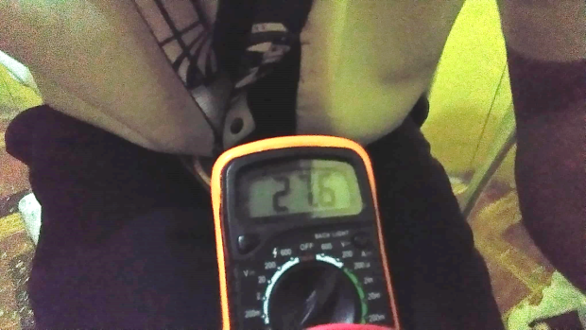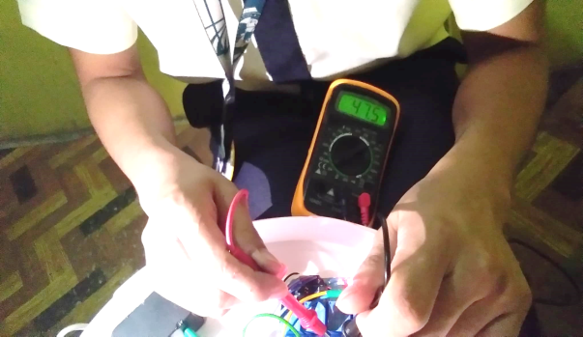

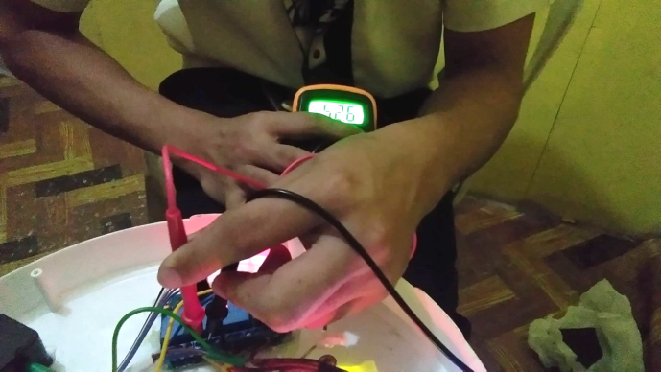

**Figure 5.**

**Device Testing Prior to Energy-Efficiency Potential**

**Table 3.0**

**Testing the Traditional Fan’s Power-Consumption**

|  |  |
| --- | --- |
| **Fan Speed** | **Approximate Electricity Consumption (Traditional Fan)** |
| 1 | 23.9 Volts |
| 2 | 41.0 Volts |
| 3 | 61.1 Volts |

Table 3 shows the power consumption of a traditional electric fan similar to the desk fan used in the experiment. The fan speed one consumes 23.9 Volts of electricity. Next, the fan speed two consumes 41.0 volts of electricity, about twice the volts of fan speed 1. However, the fan speed 3 consumes 61.1 volts of electricity.

In comparison with the ATSFan, the fan speed 1 and 2 of a traditional fan have less voltage of 3.7 V and 6.5 V, respectively. While the fan speed 3 of the traditional has higher voltage of 8.5.

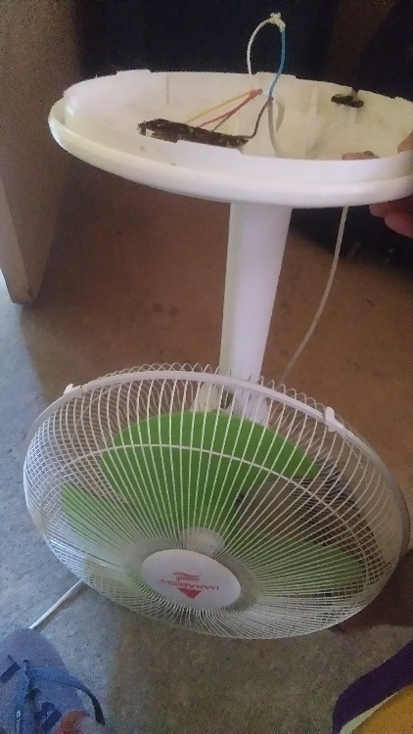 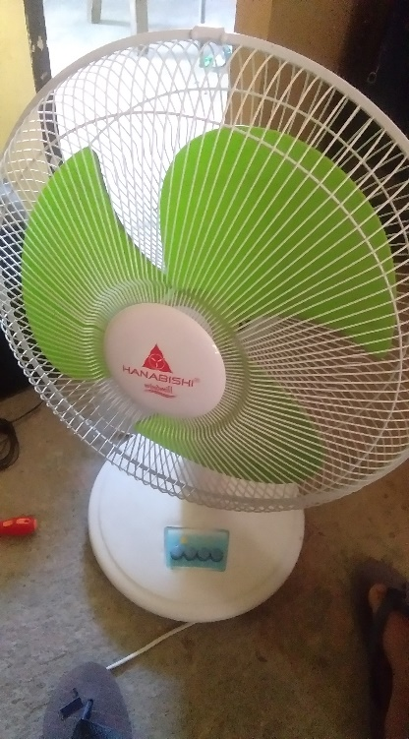 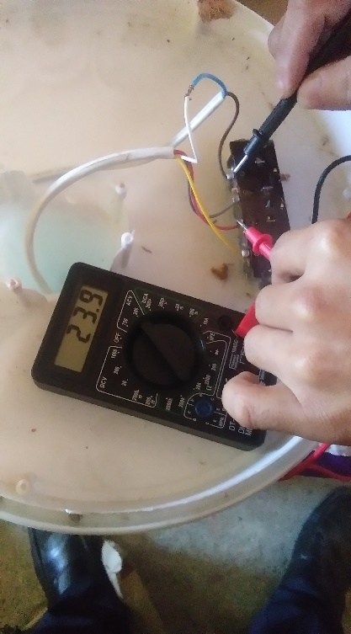

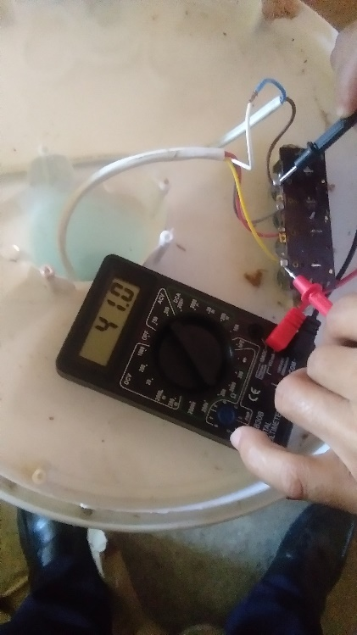 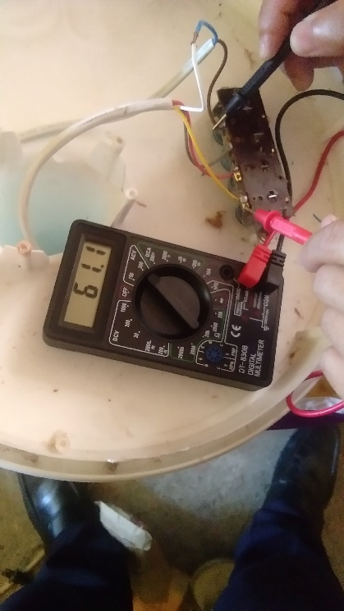

**Figure 6.**

**Testing of Traditional Fan’s Power-Consumption**

**Chapter IV**

**Summary, Conclusion and Recommendation**

This chapter presents the summary of the findings, conclusion and recommendation of the researchers.

**Summary**

The general objective of the study is to develop an energy-efficient cooling system through the reduction of electricity consumption. Specifically, it dealt with the following objectives: First, to create an automatic temperature-sensing fan. Second, to innovate a traditional electric fan to a low-cost user-friendly automatic temperature-sensing fan for reducing the power consumption and assist people who are unable to control the speed of fan from their locations. Third, to compare and contrast traditional electric fans to an automatic temperature-sensing fan in terms of power-consumption and functionality. Fourth, to determine the electricity-saving potential and cost-efficiency of an automatic temperature-sensing fan. Lastly, to examine the advantages of having an automatic temperature-sensing fan.

The following are the results revealed during the study:

1. The researchers were able to create an energy-saving, cost-efficient automatic temperature-sensing fan (it costed 2,496 pesos only).
2. The ATSFan has a better function than a traditional fan because it lessens human effort and household expenses. Also, the product is very easy to use, because it is a plug-and-play device.
3. The researchers discovered that the advantages of having an ATSFan are: First, it is a low-cost device. Second, the ATSFan helps in reducing electricity usage. Third, this device lessens human effort and is effective for the elderly and persons with disability.

**Conclusion**

The following conclusions were derived base on the results of the findings in the study:

1. The researchers were able to create an automatic temperature-sensing fan, innovating a traditional electric fan to an energy efficient cooling system which is the ATSFan, to reduce the power consumption of electricity.
2. The researchers have proved that the ATSFan consume less electricity than the traditional fan. The average consumption of the ATSFan ranges from 27.6 to 51.6 Volts, while the traditional electric fan ranges from 23.4 to 61.1 Volts. In terms of functionality, the automatic temperature-sensing fan lessens the human effort through infrared remote control and enables the automatic change of fan speed according to the room temperature. Thus, the ATSFan is more convenient than the traditional electric fan since it can sense the temperature of the room and change its fan speed without human effort, and results to reduction of consumption of electricity.Top of Form
3. The researchers were able to determine the electricity-saving potential of the Automatic Temperature Sensing Fan with the use of the multi meter tester. Also, the ATSFan is a low price, budget-friendly device.

**Recommendation**

1. A warning alarm can also be installed to avoid overheating of the electric fan by detecting if the temperature of the device/system reach a certain undesirable limit.
2. Addition of automatic turn-off circuit can also be done; if the device sensed too low temperature it will automatically turn off.

**Bibliography**

**Appendix A**

**Code of Arduino**

/***************************************************

Temp based Efan

v1.0.0

***************************************************/

// LCD

#include <LiquidCrystal_I2C.h>

// DHT22

#include "DHT.h"

#define DHTTYPE DHT22

#define TITLE "TIMER BASED EFAN"

#define VERSION "1.0.0"

// PINS

#define DHTPIN 2

#define RELAY_PIN_1 3

#define RELAY_PIN_2 4

#define RELAY_PIN_3 5

#define IS_INVERTED true

// CONDITIONS

#define TEMP_1 20 //

#define TEMP_2 25

#define TEMP_3 28

#define OFF LOW

#define ON HIGH

// LCD

LiquidCrystal_I2C lcd(0x27,16,2); // set the LCD address to 0x27 for a 16 chars and 2 line display

// DHT

DHT dht(DHTPIN, DHTTYPE);

void setup() {

Serial.begin(9600);

Serial.println("-START-");

Serial.println(TITLE);

Serial.println(VERSION);

relaySetup();

lcdSetup();

// " ");

lcd.setCursor(2,0);

lcd.print("AUTO. TEMP.");

lcd.setCursor(2,1);

lcd.print("SENSING FAN");

dhtSetup();

delay(2000);

lcd.clear();

}

void loop() {

delay(2000);

static float c = 0.00;

readTemperature(&c);

displayTemperature(c);

static int fan = 0;

decide(c, &fan);

displayStatus(fan);

}

void readTemperature(float *c) {

*c = dht.readTemperature();

if (isnan(*c)) {

Serial.println(F("Failed to read from DHT sensor!"));

return;

}

}

void displayTemperature(float c) {

// " ");

lcd.setCursor(0,0);

lcd.print(" Temp: ");

lcd.print(c);

lcd.print(" C ");

Serial.print(F("Temperature: "));

Serial.print(c);

Serial.println(F("Â°C "));

}

void decide(float c, int *fan) {

if (c < TEMP_1) {

*fan = 0;

}

else if (c >= TEMP_1 && c <= TEMP_2) {

*fan = 1;

}

else if (c > TEMP_2 && c <= TEMP_3) {

*fan = 2;

}

else if (c > TEMP_3) {

*fan = 3;

}

turnFan(*fan);

}

void turnFan(int num) {

Serial.println(num);

if (num == 0) {

turnRelay(RELAY_PIN_1, OFF, IS_INVERTED);

turnRelay(RELAY_PIN_2, OFF, IS_INVERTED);

turnRelay(RELAY_PIN_3, OFF, IS_INVERTED);

}

else if (num == 1) {

turnRelay(RELAY_PIN_2, OFF, IS_INVERTED);

turnRelay(RELAY_PIN_3, OFF, IS_INVERTED);

delay(50);

turnRelay(RELAY_PIN_1, ON, IS_INVERTED);

}

else if (num == 2) {

turnRelay(RELAY_PIN_1, OFF, IS_INVERTED);

turnRelay(RELAY_PIN_3, OFF, IS_INVERTED);

delay(50);

turnRelay(RELAY_PIN_2, ON, IS_INVERTED);

}

else if (num == 3) {

turnRelay(RELAY_PIN_1, OFF, IS_INVERTED);

turnRelay(RELAY_PIN_2, OFF, IS_INVERTED);

delay(50);

turnRelay(RELAY_PIN_3, ON, IS_INVERTED);

}

}

void displayStatus(int f) {

lcd.setCursor(0,1);

lcd.print(" Fan: ");

lcd.print(f);

Serial.print(" Fan: ");

Serial.println(f);

}

void turnRelay(int pin, bool status, bool isInverted) {

if (isInverted) {

status = !status;

}

digitalWrite(pin, status);

}

void lcdSetup() {

lcd.init();

lcd.backlight();

}

void dhtSetup() {

dht.begin();

}

void relaySetup() {

pinMode(RELAY_PIN_1, OUTPUT);

pinMode(RELAY_PIN_2, OUTPUT);

pinMode(RELAY_PIN_3, OUTPUT);

turnRelay(RELAY_PIN_1, OFF, IS_INVERTED);

turnRelay(RELAY_PIN_2, OFF, IS_INVERTED);

turnRelay(RELAY_PIN_3, OFF, IS_INVERTED);

}

**Appendix B**

**Curriculum Vitae**

**MARK HARRIS Q. BORREO**

**Personal Information**

Address: Brgy. Umiray, General Nakar, Quezon, N.E.

Birthday: October 29, 2001

**Educational Attainment**

**Primary** Cynthia Village Elementary School

2014

**Secondary** High School: Paaralang Sekundarya ng Heneral Nakar Umiray Extension

2018

Senior High School: PHINMA - Araullo University (Grade 11-12)

2019 - present



**PHILLIZE M. CALDERON**

**Personal Information**

Address: Sampaguita St., Platero, Gen. Mamerto Natividad, N.E.

Birthday: Feb. 27, 2002

**Educational Attainment**

**Primary** Platero Elementary School

Valedictorian

2014

**Secondary** High School: Eduardo L. Joson Memorial High School

2nd Honor

2018

Senior High School: PHINMA - Araullo University (Grade 11-12)

With Honor

2019 - present



**FERVILYN E. CORPUZ**

**Personal Information**

**Address: Saranay 1st, Maragol Science City of Munoz, Nueva Ecija.**

**Birthday: March 3, 2002**

**Educational Attainment**

**Primary** Maragol Elementary School

2nd Honorable Mention

2014

**Secondary** High School: Maragol Integrated School

1ST Honor

2018

Senior High School: PHINMA – Araullo

University

With Honor

2019 - present



**DENNIS P. DELA CRUZ**

**Personal Information**

**Address:** Purok L.O, Bangad, Cabanatuan City, N.E.

**Birthday:** August 3, 2001

**Educational Attainment**

**Primary** L.O Francisco Elementary School

2014

**Secondary** High School: Nueva Ecija High School

2018

Senior High School: PHINMA - Araullo University (Grade 11-12)

2019 - present



**ANGELIKA C. ENCOMIENDA**

**Personal Information**

**Address: Sto. Cristo, San Isidro, N.E.**

**Birthday: March 25, 2002**

**Educational Attainment**

**Primary** Sto. Cristo Elementary School

Salutatorian

2014

**Secondary** High School: General de Jesus College

With High Honors

2018

Senior High School: PHINMA - Araullo University

With High Honors

2019 – present



**RHEN KAIRA F. ESTIMADA**

**Personal Information**

**Address:** Narra 1, Bitas, Cabanatuan City, Nueva Ecija

**Birthday:** Sept. 10, 2002

**Educational Attainment**

**Primary** Bitas Elementary School (Grade 1-3)

Inanama Elementary School (Grade 4-6)

Valedictorian

2014

**Secondary** High School: Honorato C. Perez Sr. Memorial Science High School

2018

Senior High School: PHINMA – Araullo

University

With Honor

2019 – present



**CLARENCE R. SAN JUAN**

**Personal Information**

**Address:** Davil-Davilan, Dingalan, Aurora

**Birthday:** May 18, 2002

**Educational Attainment**

**Primary** Dingalan Central School

13th Honor

2014

**Secondary** High School: Dingalan National High School

4th Honor

2018

Senior High School: PHINMA – Araullo

University (Grade 11-12)

With Honor

2019 – present

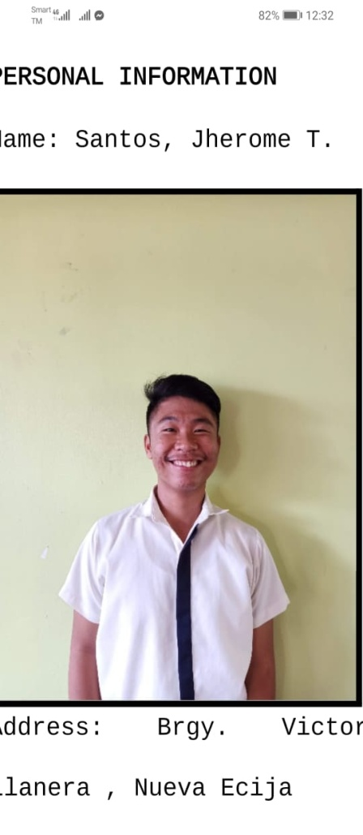

**JHEROME T. SANTOS**

**Personal Information**

**Address:** Brgy. Victoria, Llanera, Nueva Ecija

**Birthday:** Feb. 26, 2002

**Educational Attainment**

**Primary** Llanera Central School

2014

**Secondary** High School: Llanera National High School

2018

Senior High School: PHINMA – Araullo

University (Grade 11-12)

2019 – present



**JOMAR L. SICUAN**

**Personal Information**

**Address:** Burgos, Carranglan, N.E.

**Birthday:** Sept. 28, 2000

**Educational Attainment**

**Primary** Burgos Elementary School

2014

**Secondary** High School: Burgos National High School

2018

Senior High School: PHINMA – Araullo

University (Grade 11-12)

2019 – present

****Bottom of Form

**JUSTIN PAUL P. VILLAROMAN**

**Personal Information**

Address: Ibuna, Dingalan, Aurora

Birthday: May 7, 2002

**Educational Attainment**

**Primary** Matawe Dingalan Aurora Elementary School

2014

**Secondary** High School: Dingalan National High School

2018

Senior High School: PHINMA - Araullo University (Grade 11-12)

2019 – present